

**PROJECT REPORT**

# Cinema Ticketing

|  |  |
| --- | --- |
| **Semester:** | Programming Fundamentals |
| **Class:** | PF1117 |
| **Group:** | SoloSquad |
| **Instructor** | Cường |
| **Team members:** | Mai Văn Tiến |

# Index

Project Name 1

Index 2

I. Project introduction 3

II. Analyze System Requirements 3

III. Design Details 8

IV. Test 14

V. Task Assign (to each team member) 15

VI. Installation Instructions 16

Appendix 17

Document format 18

# Project introduction

Briefly describe the operation of the system to which the project will be applied

...

1. Proposed System

...

1. The scope of the project to be applied

...

1. System Name

...

1. Deployment Environment

...

1. Development Tools

...

1. Customer Requirements (System features)
   1. Functional Requirements
   2. External Interface Requirements
   3. System Features
   4. Nonfunctional Requirements

# Analyze System Requirements

1. Use Case

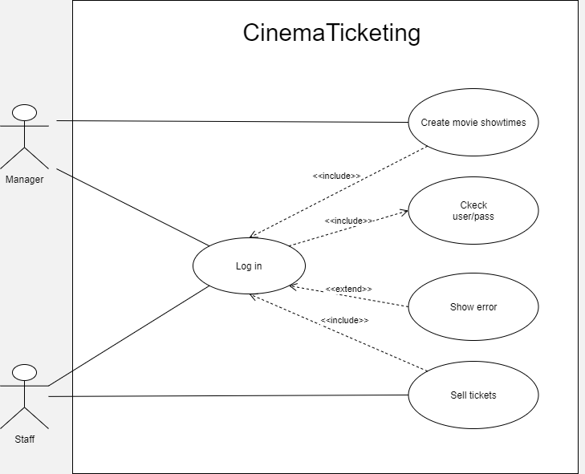

1. Activity Diagram:

2.1 Login

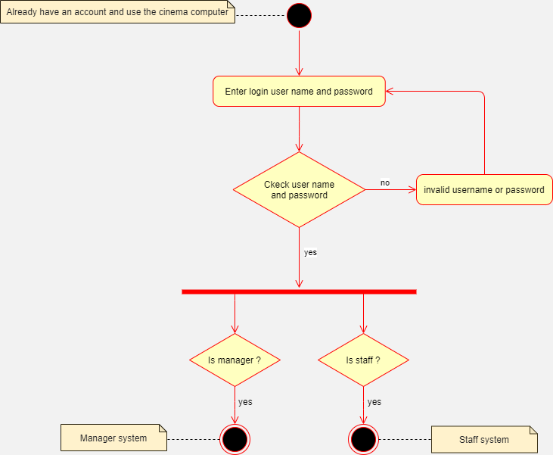

2.2 Manager Cinema

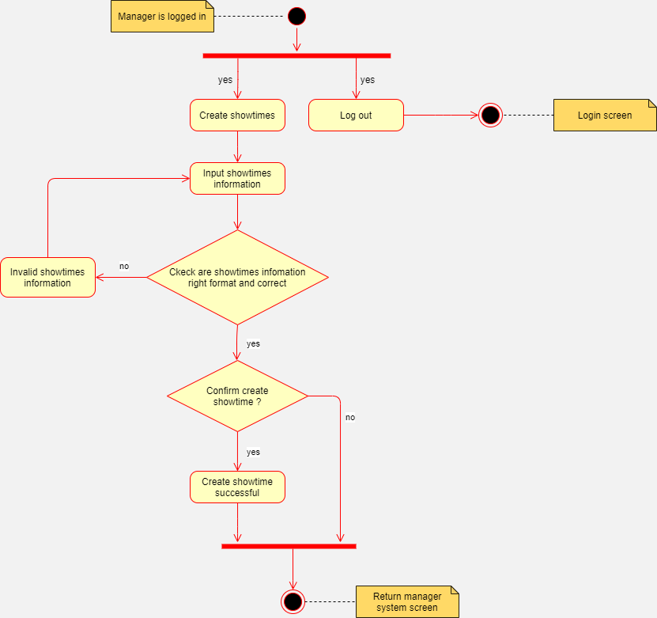

2.3 Staff Cinema

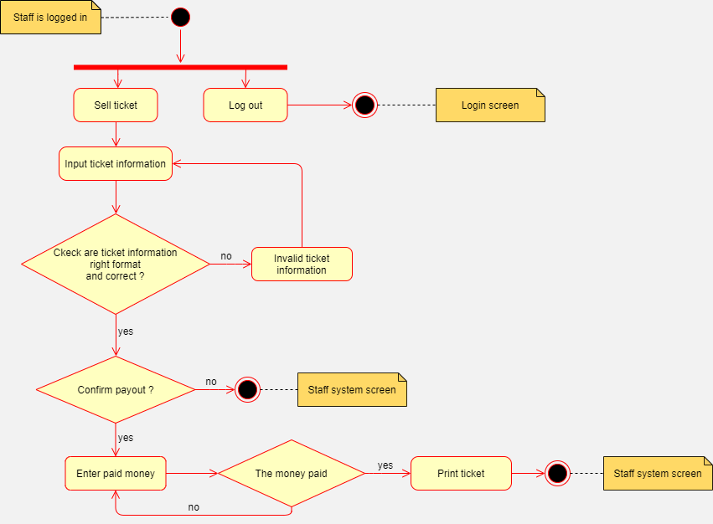

# Design Details

1. Code Design (Class Diagram)

(Class Diagram):

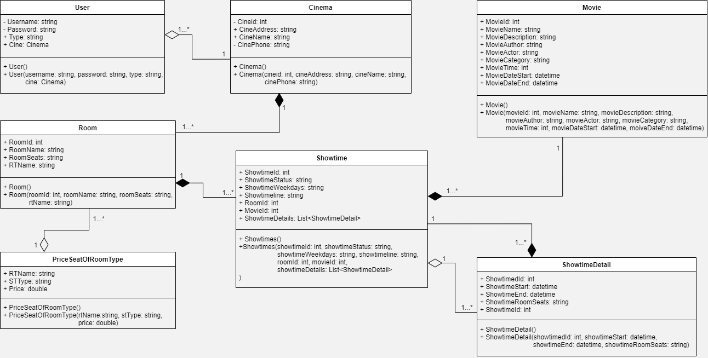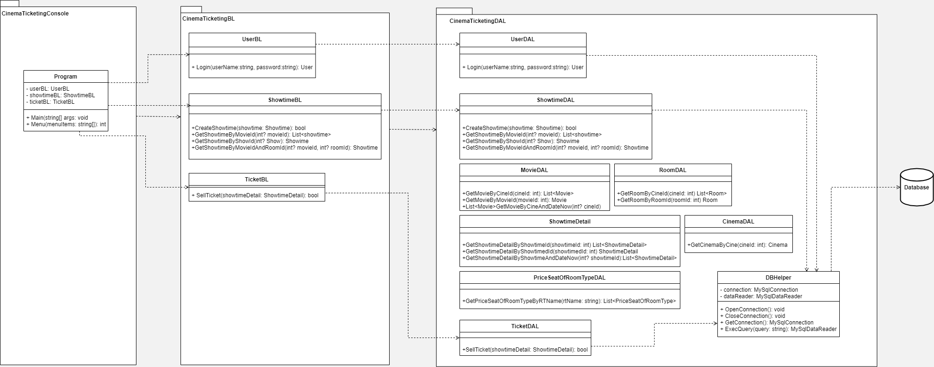

1. Sequence Diagram

2.1 Login

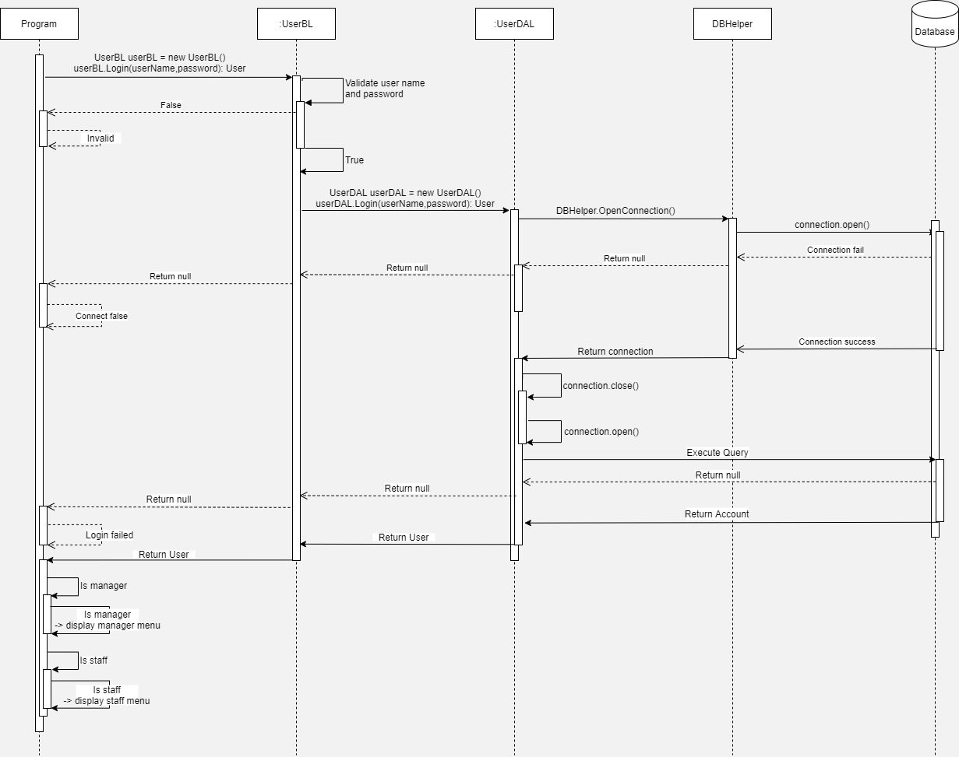

2.2 Showtimes

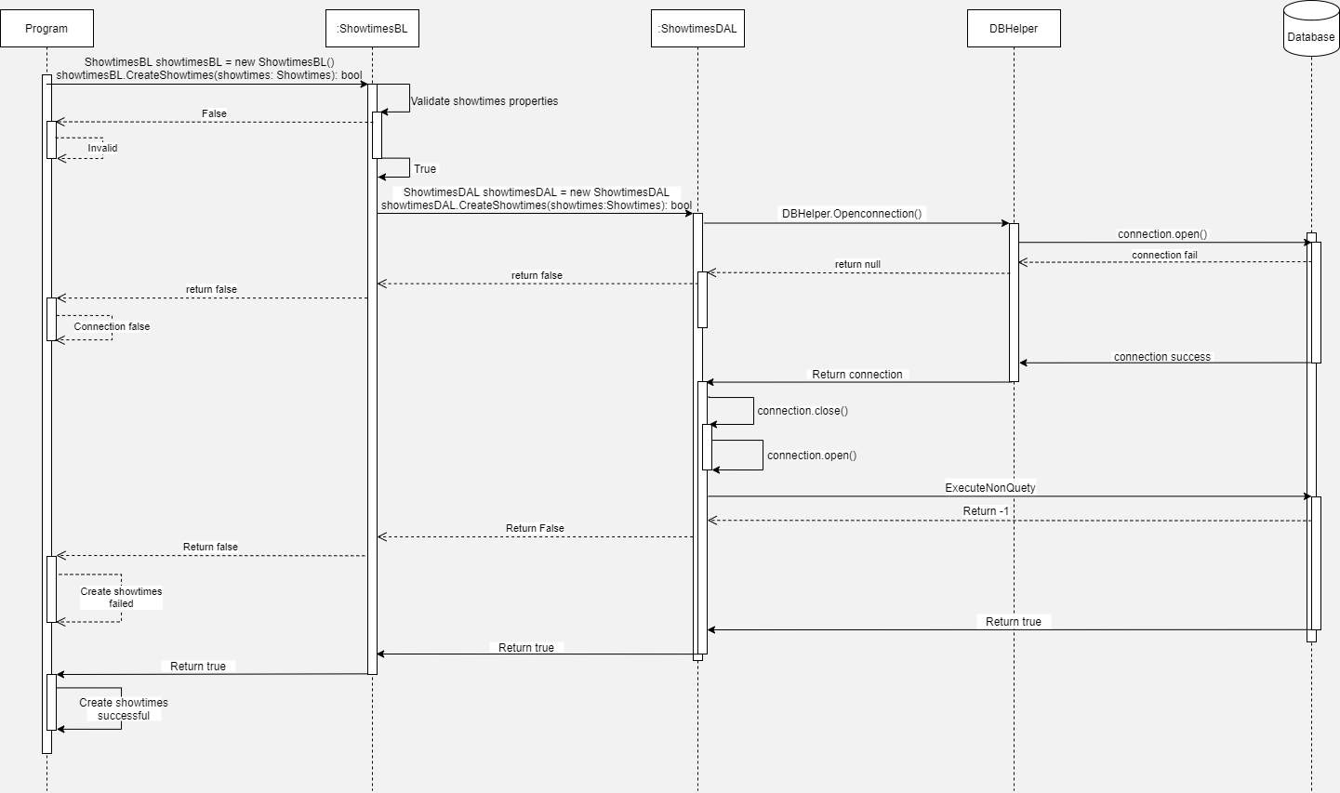

2.3 Sell Ticketing

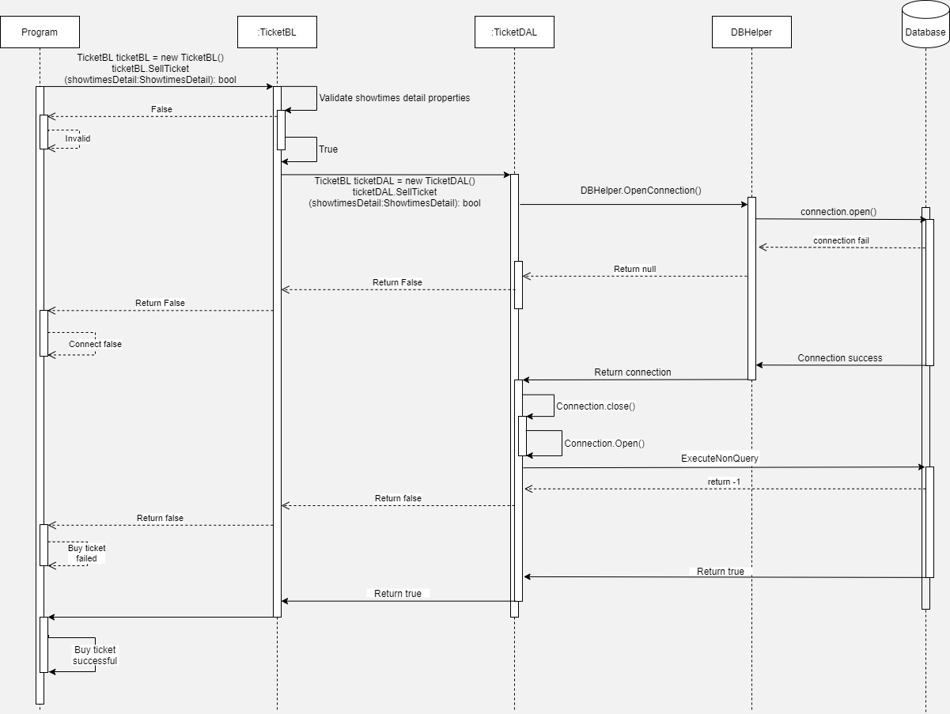

1. Database Design
   1. Entity Relationship Diagram

